**Author Permissions**

**Easy-to-Build Textile Pressure Sensor**

Dr. Francisco Pizarro - ([francisco.pizarro.t@pucv.cl](mailto:francisco.pizarro.t@pucv.cl))

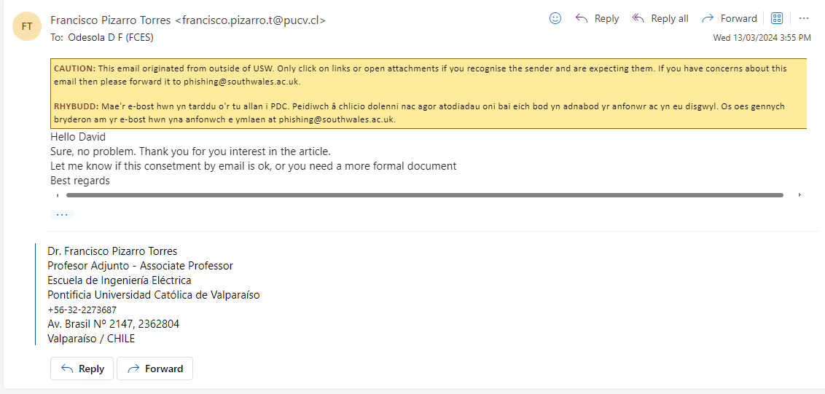

**A Smart Chair to Monitor Sitting Posture by Capacitive Textile Sensors**

Marc Martinez Estrada ([marc.martinez.estrada@upc.edu](mailto:marc.martinez.estrada@upc.edu))

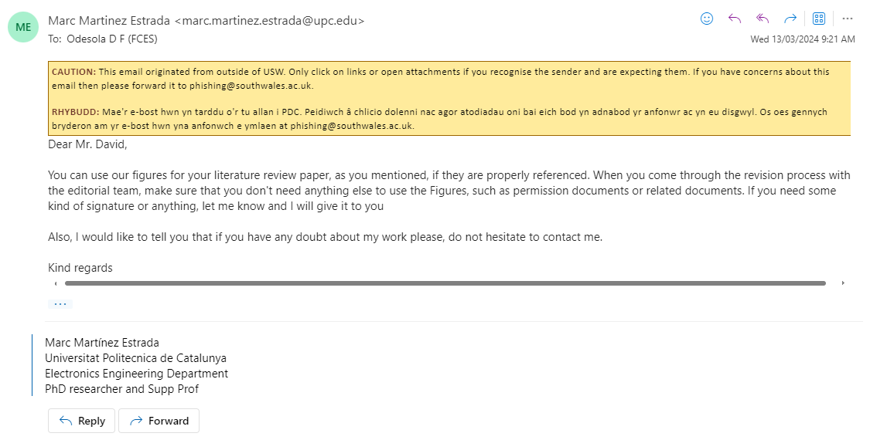

**Development of a Smart Chair Sensors System and Classification of Sitting Postures with Deep Learning Algorithms**

Taraneh Aminosharieh Najafi ([taraneh.aminoshariehnajafi@epfl.ch](mailto:taraneh.aminoshariehnajafi@epfl.ch))

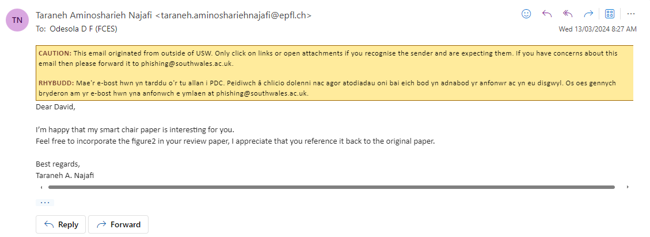

A Smart Chair to Monitor Sitting Posture by Capacitive Textile Sensors

Tiina Vuohijoki ([tiina.vuohijoki@tuni.fi](mailto:tiina.vuohijoki@tuni.fi))



**Robust, Low-cost, Non-intrusive Sensing and Recognition of Seated Postures**

Dr. Bilge Mutlu (bilge@cs.wisc.edu)

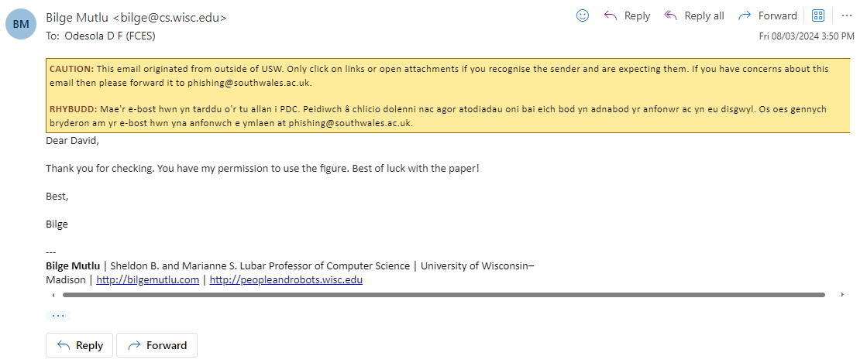

**A portable sitting posture monitoring system based on a pressure sensor array and machine learning.**

Bin Chen ([chenbin121@swu.edu.cn](mailto:chenbin121@swu.edu.cn))

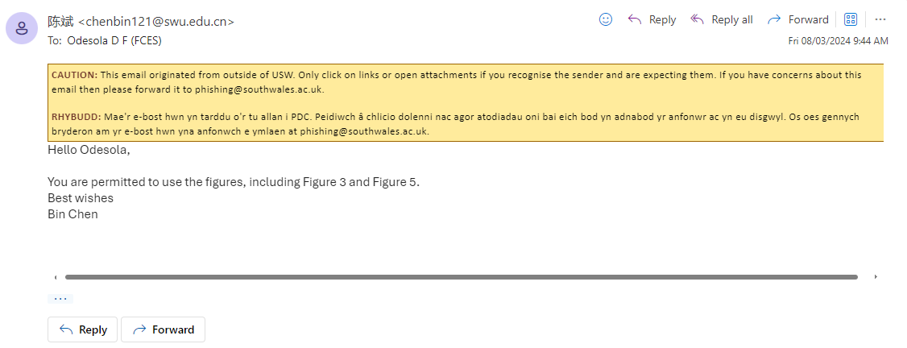

As per the directive from the Managing Director of MDPI Sensors, it is affirmed that the copyright ownership resides with the authors of the respective works. Furthermore, it is explicitly stated that figures contained within these works may be utilized freely, provided proper citation and acknowledgment are duly attributed.A white background with black text
